 | Jesus’ Special Supper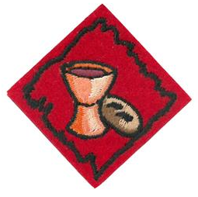
 | Tell the story of the Last Supper.  Review the story in e-club class  𝥷 I told the story to someone special
Explain why Jesus washed the disciples’ feet as a servant.  𝥷 I listened 𝥷 I explained to someone special |  | 
 | Explain what the bread and the juice represents.  Draw lines → match meaning   Jesus’ Body   Jesus’ blood
What happened at the end of the special supper? (circle all that happened)  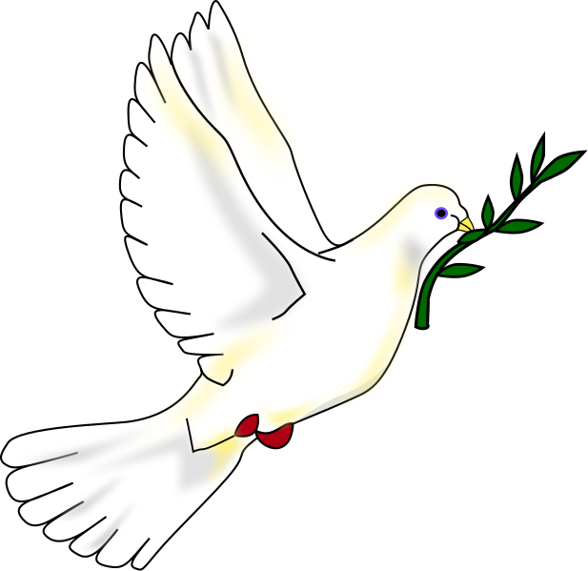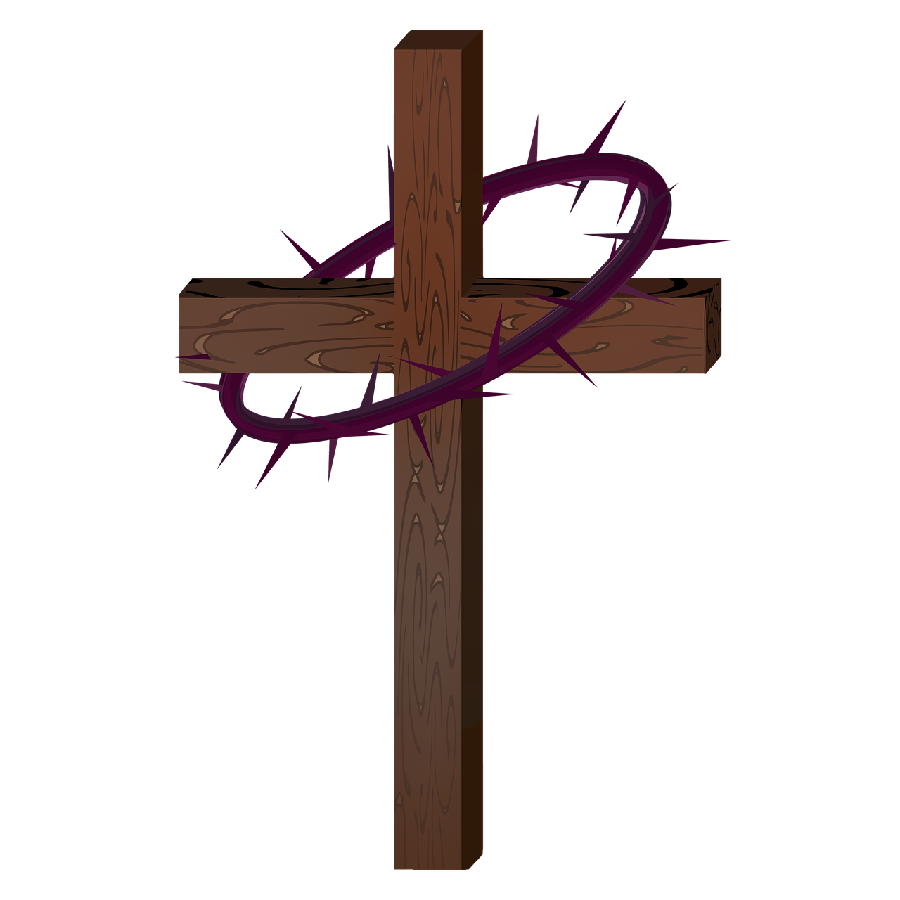 |  | 
 | Make a craft to illustrate the Last Supper..  𝥷 I sent a photo of my craft to dejan@adventist.uk
Have a prayer thanking Jesus for HIS love.  𝥷 I prayed with Pr. Mark or my family. |  | 

