
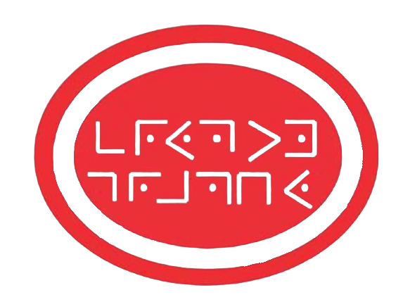

Cryptography

British Union e-Honour

Cryptography e-Honour Worksheet (Instructor & creator: Simon Siew, Singapore)

- Cryptography or cryptology is the art of c__________________ messages in order to keep them private or confidential.

When the message is encoded, only those who have been given the k________ or code book will know how to decode the secret message.

Steganography is the art of hiding the message with a ‘c___________’ so that what people see is the cover without realizing there is a secret message hidden within or under it.

- Decryption is the r_____________ process where we convert the unintelligible cipher text back to plain text (normal text).

- The word cypher comes from the Arabic word SIFR meaning ‘empty’ or z________.

- Scytale in Greek means a b_______________.

- The first Enigma was invented by G___________ engineer Arthur Scherbius at the end of World War 1.

- Code talkers refer to N____________ A________________ soldiers who talk using a coded language to transmit secret messages over the radio.

- The Navajo language was an u_________________ language and no books in Navajo had ever been published.

- The decree by Ptolemy V written on the Rosetta Stone appears in appears in t_______ languages.

- In Bible prophecy, the bear represents the Kingdom of M_________________________.

- A transposition cipher is a method of encryption by which the positions held by units of plaintext are s_____________ according to a regular system to create the cipher text.

- A substitution cipher is a method of encryption by which the units of the plain text are r_____________ with other symbols which need not be the same as those used in the plain text.

- A) Show your answers for the test items in the presentation.
b) Make a scytale example.

