

Pizza Maker
British Union e-Honour
Requirements:
- Briefly research the history of pizza.

2. List the basic ingredients for a pizza dough.

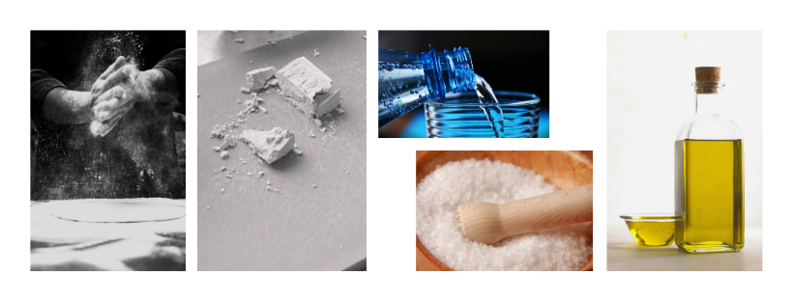
3. Find out at least one biblical text about each single ingredient.
Explain at least 4 of these texts and their symbolic meaning.

4. Describe the leavening process.

5. What is the difference between Neapolitan style pizza and Roman style pizza?

6. According to its shape and size, how many kinds of pizza do you know?

7. What are three different ways to bake a pizza? Describe the differences in detail.

8. What is the ideal temperature if you use a wood oven to cook pizza?
What is the ideal temperature if you use an electric oven?

9. Prepare a Pizza Margherita. It can of course be made with vegan toppings.
Take a photo of your bake for your club folder.

