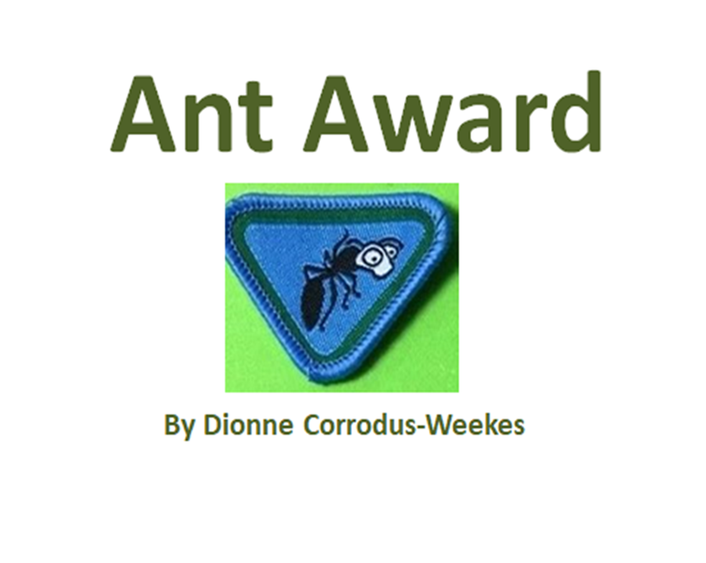

How to Make Egg Carton Ants

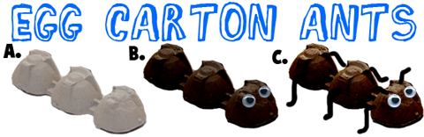

Instructions
- Cut a group of 3 egg cups out of an egg carton, as seen in illustration A above.
- Paint egg carton black or use a marker to colour them black, brown or you could use red.
- Glue googly eyes on the front of the ant body.
- Poke holes on the side of the ant and on the top of the ant's head.
- Use pieces of pipe cleaners for legs...push them into the holes and anchor by bending the pipe cleaner on the inside.
- Optionally, an adult can hot glue the pipe cleaner on

Learn and sing the ant song "the ants go marching ....."
http://www.youtube.com/watch?v=ARfLaNJcpsw
The ants go marching one by one, Sabbath, hurrah
The ants go marching two by two, Sabbath, hurrah
The ants go marching three by three,
The little one stops to climb a tree
And they all go marching down to the ground
To get out of the rain, BOOM! BOOM! BOOM!
The ants go marching four by four, Sabbath, hurrah
The ants go marching five by five, Sabbath, hurrah
The ants go marching six by six,
The little one stops to pick up sticks
And they all go marching down to the ground
To get out of the rain, BOOM! BOOM! BOOM!
The ants go marching seven by seven, Sabbath, hurrah
The ants go marching eight by eight, Sabbath, hurrah
The ants go marching nine by nine,
The little one stops to check the time
And they all go marching down to the ground
To get out of the rain, BOOM! BOOM! BOOM!

The ants go marching ten by ten,
The little one stops to say "The End",
And they all go marching down to the ground
To get out of the rain
BOOM! BOOM! BOOM!
BOOM! BOOM! BOOM!

(Adapted)
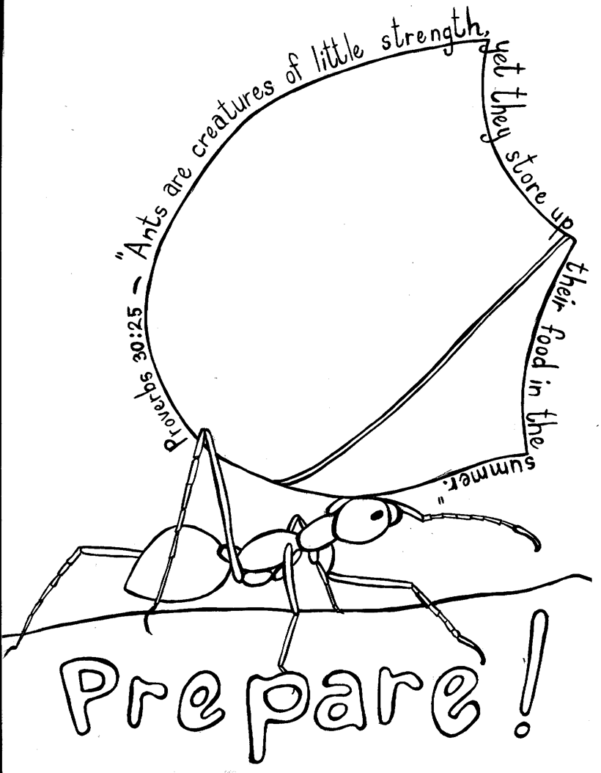
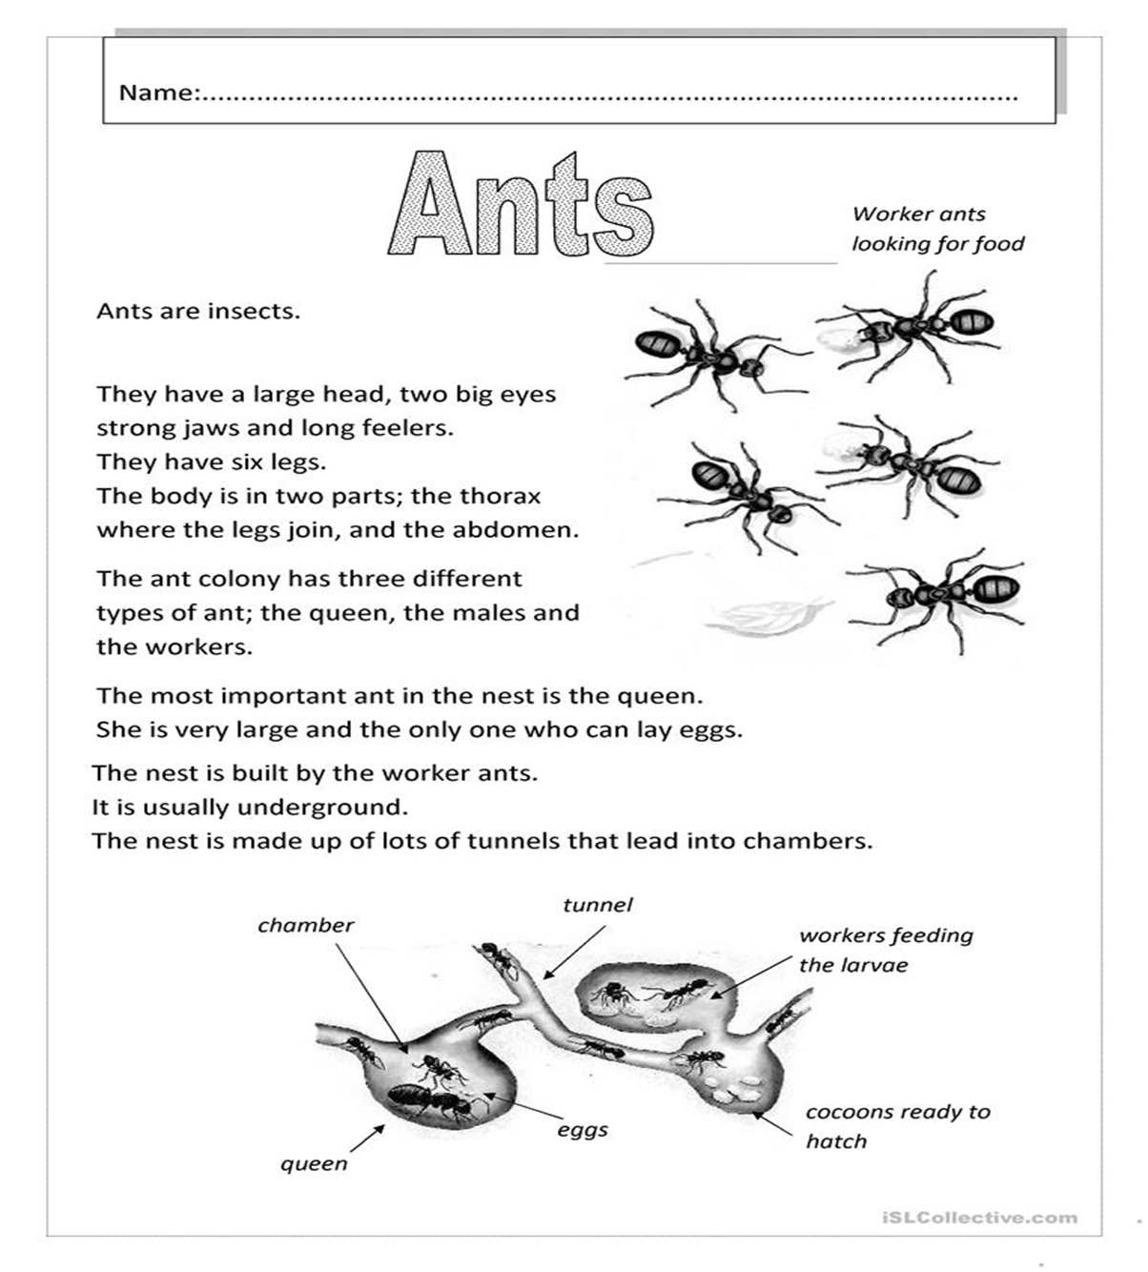

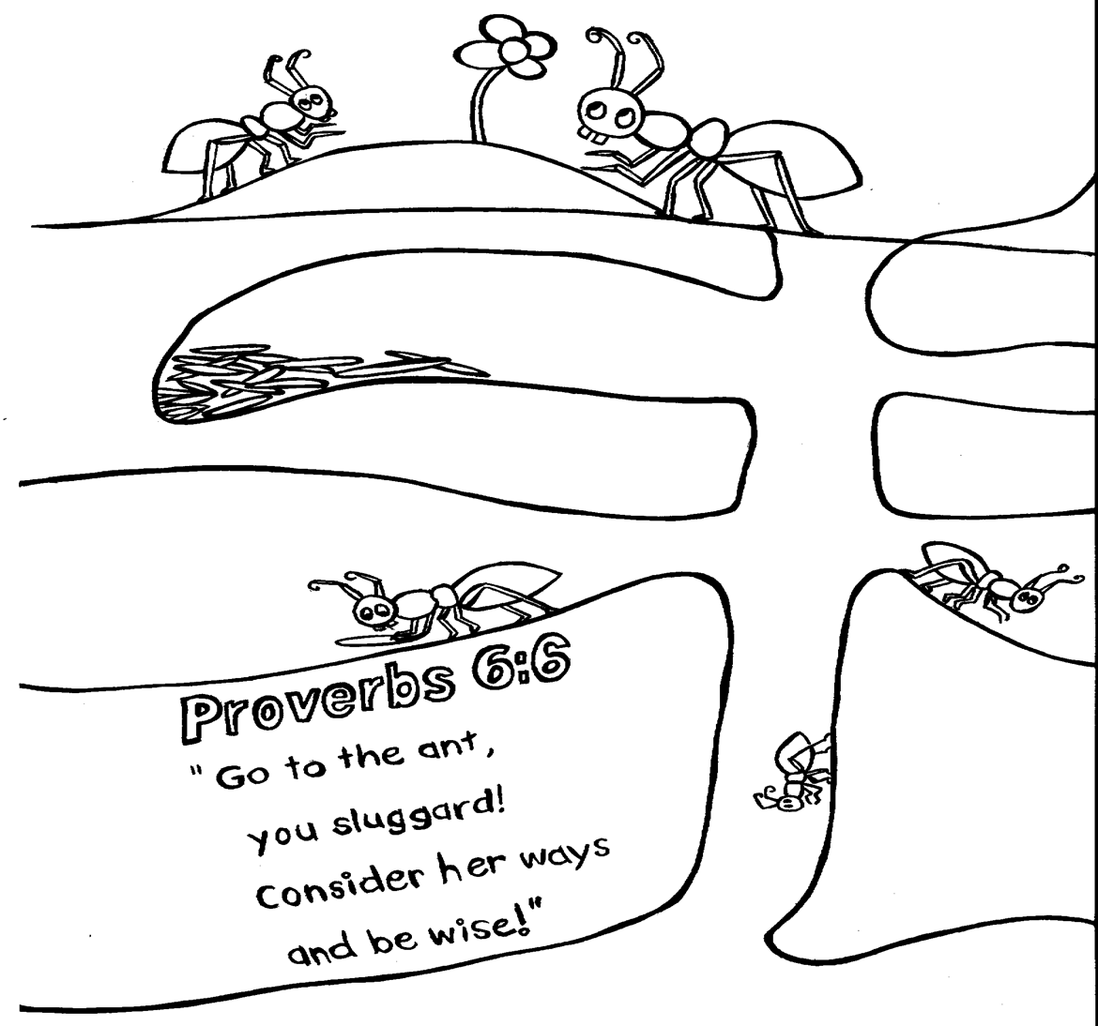

How to Make an Ant Farm Jar and Watch an Ant Colony Build Mazes
This is a great project for kids who are interested in nature and bugs to do . This is an easy project for kids of any age and a supervising adult to do as you get to watch ants build an underground city…so it is pretty cool.

This ant farm has no openings, so you don’t have to worry about the ants escaping. Let a responsible adult open the jar outside to feed the ants, close it back and bring it inside ready for you to observe.
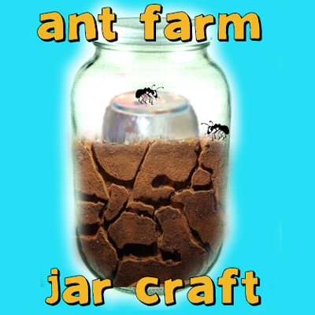

How To Make An Ant Farm Jar - Watch An Ant Colony Build Mazes

Crafts Materials Needed
- 2 Jars – One Big, One Smaller
- Loose, Sand-Like Soil
- Water
- Sugar

Step 1
Clean both jars out, and dry them out. Take the outside wrappers off so you will be able to see inside the ant jar.

Step 2
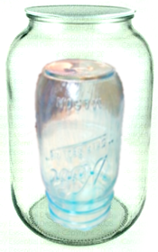
Put the smaller jar, without its lid, upside down, within the bigger jar. Try to center it. Poke a few tiny holes in the jar lid, small enough for ants to not escape
Reference
http://www.artistshelpingchildren.org/kidscraftsactivitiesblog/2011/02/how-to-make-an-ant-farm-jar-and-watch-an-ant-colony-build-mazes/

