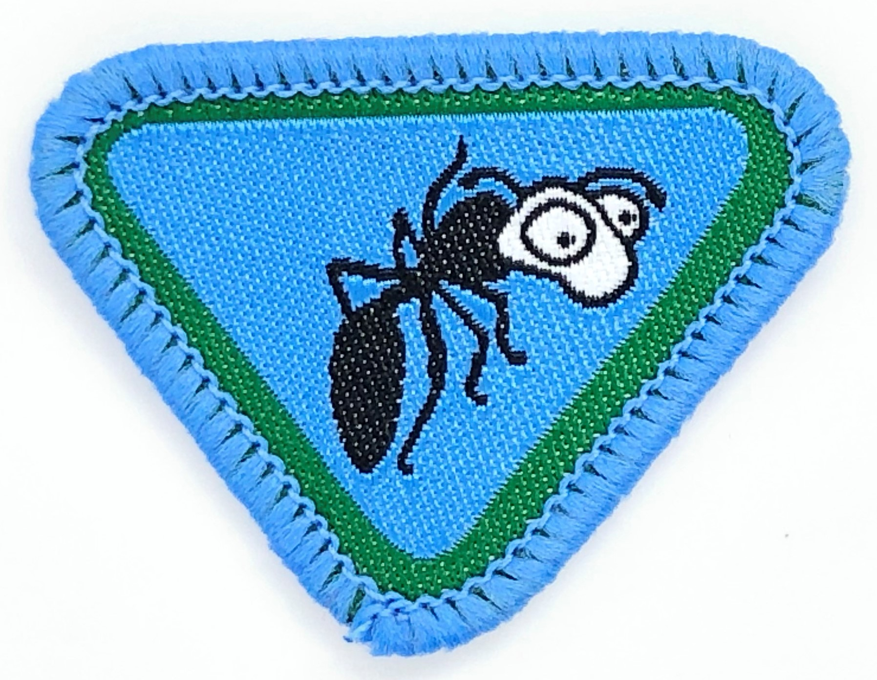
Ants
By Dionne Corrodus-Weekes (Dagenham, SEC) - 30/12/2013
Requirements:

- What is an ant?

Ants are _____________________ ____________________ known for working_________________ and being ______________________.
strong social hard insects

2a. What does the Bible say about ants in Proverbs 30:24-25?

There are _________________ things which are little on the _________________, But they are exceedingly _________________:25 The _________________ are a people not _________________, Yet they _________________ their food in the _________________ ; (NKJV)

ants four wise summer strong prepare earth

2b. Learn and explain Proverbs 6:6-8

Go to the ant, you _________________! Consider her _________________ and be _________________, Which, having no _________________, Overseer or ruler, Provides her _________________ in the summer, And _________________ her food in the harvest.

gathers sluggard ways wise captain supplies

3. How do ants communicate?

Communication is crucial to the survival of ants. Ants communicate with each other using ______________________________ (scent), _________________, and _________________.

sounds touch pheromones

4. Name four main body parts of the ant.

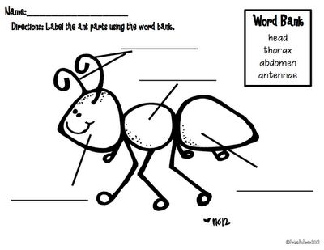

4a.What do ants use their jaws to do?

The ant head has two s_________________ jaws, (the mandibles), used to c_________________ food, manipulate o_________________, c___________________________ nests, and for d__________________.
Ants d_________________ and a_________________ themselves by b________________ and, in many species, by s_______________________, often injecting or spraying chemicals such as f__________________ a___________________.

attack strong defend carry objects biting
construct stinging defence formic acid

4b. Why do ants have "hooked claws"?

Ants have hooked claws at the end of each _________________ which helps them to _________________ and to _________________ onto surfaces.

leg climb hang

5a. Observe a group of ants in its colony and keep a log of their activity for 10 minutes.

Time  (mins) | Observations
2
4
6
8
10

5b. Discuss and list ten things you have learnt and/or observed from ants.

Draw a line to match the lessons learnt.

Observation of ants |  | Pray that you will be…
Ants are self-motivated |  | Adventurers that build together
Ants are extremely organized |  | Adventurers that are hard workers
Ants run away fast when something harmful is around |  | Adventurers that are be clean and tidy
Ants understand their gifts and work within their specific abilities |  | Adventurers that have single focus in completing a task
Ants build together |  | Adventurers that take rest  seriously including the Sabbath
Ants have single focus |  | Adventurers that are extremely  organized
Ants help and share with others |  | Adventurers that are self-motivated
Ants are team players |  | Adventurers that help and share  with others
Ants are hard workers |  | Adventurers that understand their  gifts and work within their specific abilities
Ants take rest seriously |  | Adventurers that are team players
Ants are clean and tidy |  | Adventurers that run away fast  when something harmful is around

6. Make an ant craft

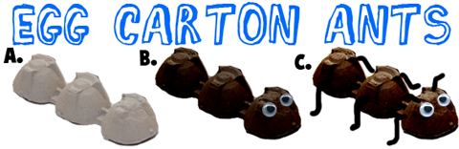

- Cut a group of 3 egg cups out of an egg carton, as seen in illustration A above.
- Either paint them black or use a marker to colour them black (or you could use red). Glue googly eyes on the front of the ant body.
- Poke holes on the side of the ant and on the top of the ant's head. Then use pieces of pipe cleaners for legs...push them into the holes and anchor by bending the pipe cleaner on the inside. Optionally, an adult can hot glue the pipe cleaner on
Craft made on: ___________ / ____________ / ______________

7. Learn and sing the ant song "the ants go marching ....."

http://www.youtube.com/watch?v=ARfLaNJcpsw

The ants go marching one by one, hurrah, hurrah
The ants go marching two by two, hurrah, hurrah
The ants go marching three by three,
The little one stops to climb a tree
And they all go marching down to the ground
To get out of the rain, BOOM! BOOM! BOOM! BOOM! BOOM! BOOM! BOOM! BOOM!
The ants go marching four by four, hurrah, hurrah
The ants go marching five by five, hurrah, hurrah
The ants go marching six by six,
The little one stops to pick up sticks
And they all go marching down to the ground
To get out of the rain, BOOM! BOOM! BOOM! BOOM! BOOM! BOOM! BOOM! BOOM!
The ants go marching seven by seven, hurrah, hurrah
The ants go marching eight by eight, hurrah, hurrah
The ants go marching nine by nine,
The little one stops to check the time
And they all go marching down to the ground
To get out of the rain, BOOM! BOOM! BOOM! BOOM! BOOM! BOOM! BOOM! BOOM!
The ants go marching ten by ten,
The little one stops to say "The End",
And they all go marching down to the ground
To get out of the rain
BOOM! BOOM! BOOM! BOOM!
BOOM! BOOM! BOOM! BOOM!

