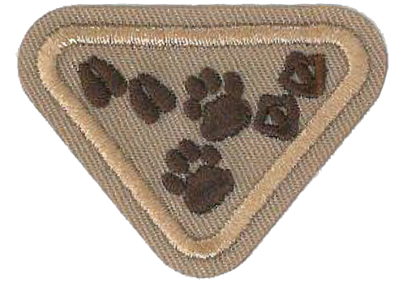
Materials list - Animal Footprints
- Worksheet printed out
- Playdough (or from PDF recipe)
- Printable Tracks Game (PDF)

